Hilton High School
Presents
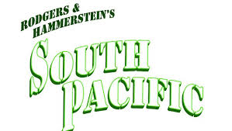
Performances Dates:
November 17th, 18th, 19th 2017
Hilton High School is excited to bring to the stage the musical “South Pacific” this November 2017. The musical program at Hilton High School is an extension of the high quality of music education provided in the Hilton Central School District. We have over 80 students participating in the musical production whether on stage or behind the scenes. With the guidance of hardworking directors, choreographers, and musicians the students are given an opportunity to participate in a fully staged musical experience.
The musical theater program is a non- profit organization that is not funded by the Hilton Central School District or New York State. The support for our production comes from the community. Once again, we are asking for your support through the purchase of advertising space in our program. With your advertisement placed in our program, over a thousand patrons will see your message prominently displayed in our program. Your advertisement is a strong reflection of your support of the Hilton music program and has a direct impact on the success of our production.
Please review the attached information for details about advertising in the program.
Thank you for your consideration and continued support.
Sincerely,

Christine Blonsky
Hilton Central School District Musical
Musical Director/Promotion
392-1000 x.2286
cblonsky@hilton.k12.ny.us

