Hilton High School
Presents
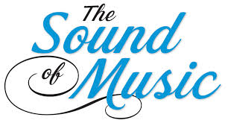
Performances Dates:
November 14th,15th , 21st, 22nd and 23rd 2014
Hilton High School is excited to bring to the stage the musical “The Sound of Music” this November 2014. The musical program at Hilton High School is an extension of the high quality of music education provided in the Hilton Central School District. This year we have over 100 students participating in the musical production whether on stage or behind the scenes. With the guidance of hardworking directors, choreographers and musicians, students are provided the opportunity to participate in a fully staged musical experience.
The musical theater program is a non- profit organization that is not funded by the Hilton Central School District or New York State. The support for our production comes from the community. Once again, we are asking for your support through the purchase of advertising space in our program. With your advertisement placed in our program, over a thousand patrons will see your message prominently displayed in our program. Your advertisement is a strong reflection of your support of the Hilton music program and has a direct impact on the success of our production.
Please review the attached information for details about advertising in the program.
Thank you for your consideration and continued support.
Sincerely,

Christine Blonsky
Hilton Central School District Musical
Promotions Director

